REQUIREMENT ANALYSIS
Data Flow Diagram & User Stories

Date | FEB 2026
Team ID | LTVIP2026TMIDS37677
Project Name | ToyCraft tales: tableau's vision into toy manufacturer data
Maximum Marks | 4 Marks

Data Flow Diagrams:
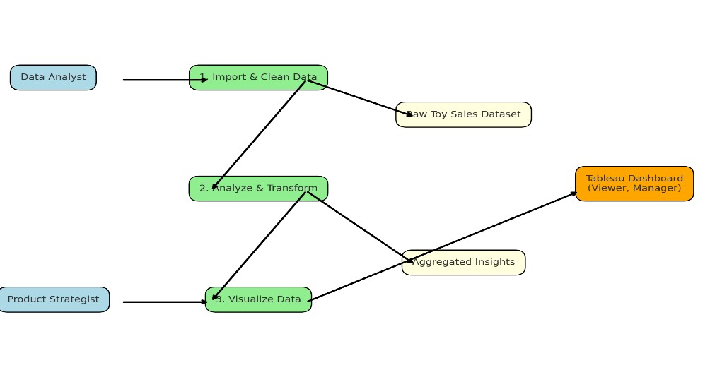

User Stories

User Type | Functional  Requirement  (Epic) | User Story  Number | User Story / Task | Acceptance criteria | Priority | Release
Data  Analyst | Data Upload | USN-1 | As a data analyst, I want to import and clean toy sales data for analysis | Data is cleaned and imported into Tableau correctly | High | Sprint-1
Data  Analyst | Data  Transformation | USN-2 | As an analyst, I want to aggregate data by category, region, and year | Aggregated dataset is ready for chart building | High | Sprint-1
Product  Strategist | Trend visualizations | USN-3 | As a strategist, I want to see annual shipment and growth trends | Trendline appears with historical context | High | Sprint-1
Marketing manager | Consumer  Behaviour Insights | USN-4 | As a marketer, I want to filter toy preferences by region and demographics | Filtered visuals update dynamically | Medium | Sprint-2
Product  Manager | Category comparision | USN-5 | As a product manager, I want to compare toy | Bar/line charts for categories are generated | Medium | Sprint-2
User Type | Functional  Requirement  (Epic) | User Story  Number | User Story / Task | Acceptance criteria | Priority | Release
 |  |  | category performance over years
Viewer | Dashboard experience | USN-6 | As a user, I want a full dashboard where I can explore all insights using filters | Dashboard loads with all visual components, slicers, and filters | High | Sprint-3

